**Valeria Mudzindiko**

**SAT 5424:Architecture Development Part 4: Installation and Configuration of Hapi-FHIR Server**

1. 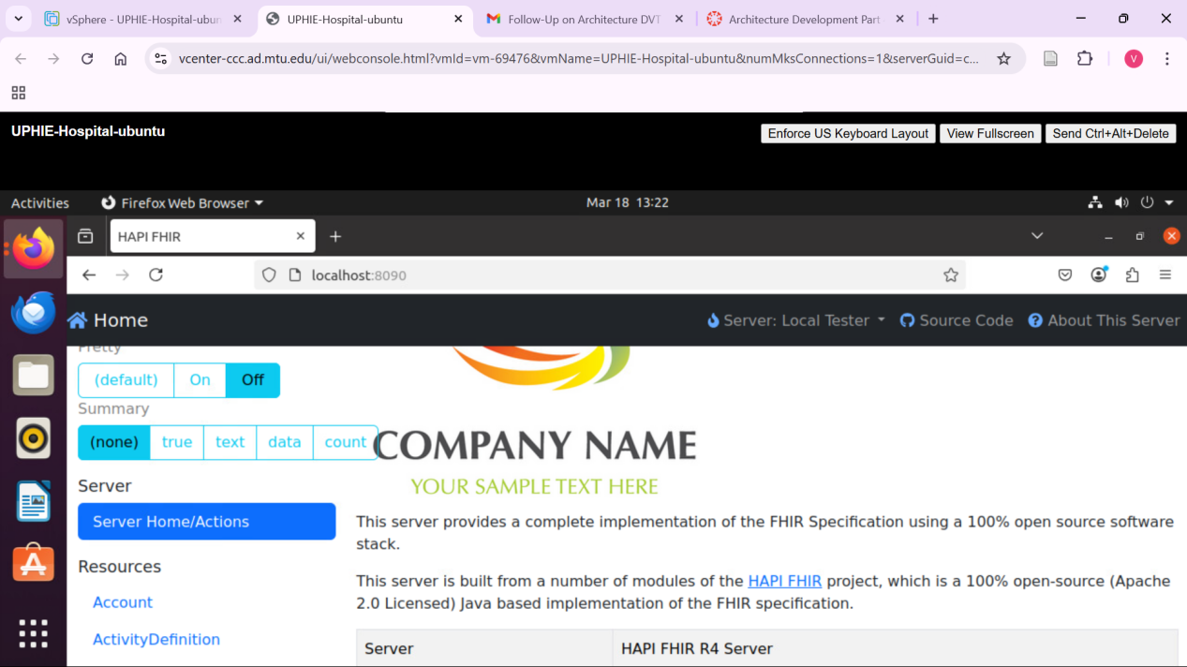
2. What command could you use to check the total, used, and free memory in system if you thought the HAPI-FHIR server was not running properly due to lack of memory?

free -h;

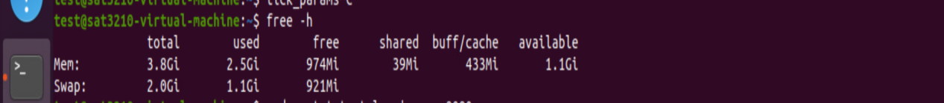

1. You've updated the firewall rules on your Ubuntu server and want to check if the port (say 8080) used by the HAPI-FHIR server is open. What command would you use?

Sudo ss -tulnp | grep 8080



1. If the HAPI-FHIR server fails to start, you want to ensure that there are no other processes occupying the default port (8080). What command should you use to check if the port 8080 is currently in use?

sudo lsof -i :8080

